TASK-1
1.TITLE: API integration and data visualization
2.INTRODUCTION:
In modern software development, data plays a crucial role in decision-making and analysis. APIs (Application Programming Interfaces) allow developers to fetch real-time data from external services, while data visualization helps in presenting that data in a meaningful and understandable way.
This project demonstrates how to integrate an API using Python and visualize the retrieved data using popular libraries.
3.OBJECTIVE:
- To understand how APIs work
- To fetch real-time data using Python
- To process and analyze data
- To create meaningful visualizations
4.TOOLS AND TECHNOLOG:
- Python
- Requests Library (for API calls)
- Pandas (for data handling)
- Matplotlib / Seaborn (for visualization)
5.API USED:
Example API: OpenWeather API (for weather data)
You can replace this with any public API.
6.PYTHON SOURCE CODE:
plt.ylabel("Temperature import requests
import pandas as pd
import matplotlib.pyplot as plt
API_KEY = "your_api_key"
CITY = "Hyderabad"
URL f"http://api.openweathermap.org/data/2.5/forecast?q={CITY}&appid={API_KEY}&units=metric"
response = requests.get(URL)
data = response.json()
dates = []
temperatures = []
for item in data['list']:
dates.append(item['dt_txt'])
temperatures.append(item['main']['temp'])
df = pd.DataFrame({
'Date': dates,
'Temperature': temperatures
})
print(df.head())
plt.figure(figsize=(10,5))
plt.plot(df['Date'][:10], df['Temperature'][:10], marker='o')
plt.xticks(rotation=45)
plt.title("Temperature Forecast")
plt.xlabel("Date")
(°C)")
plt.tight_layout()
plt.show()
6.OUTPUT:
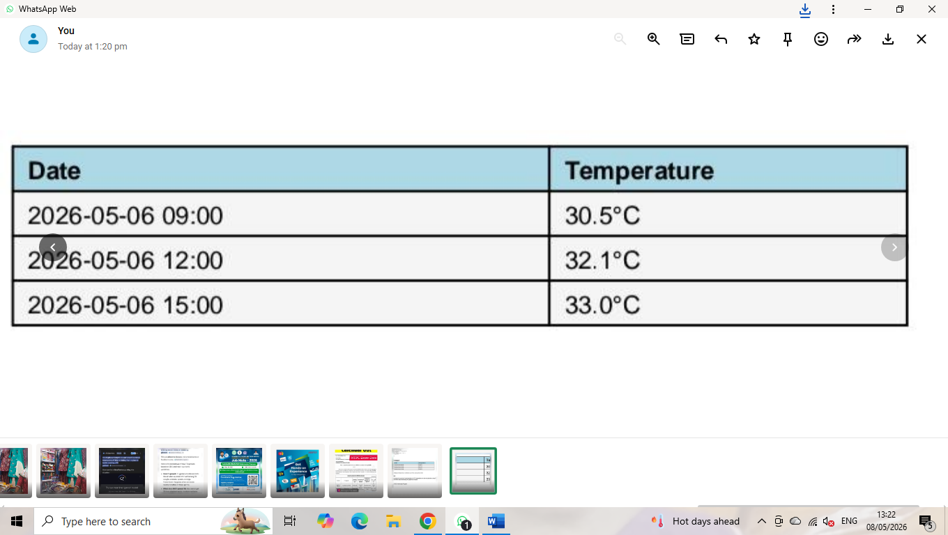
7.APPLICATION:
- Weather monitoring systems
- Stock market analysis
- Business dashboards
- Real-time analytics systems
8.CONCLUSION:
This project demonstrates how Python can be used to integrate APIs and visualize data effectively. It helps in understanding real-time data handling and presenting insights visually, which is essential in data science and software development.

